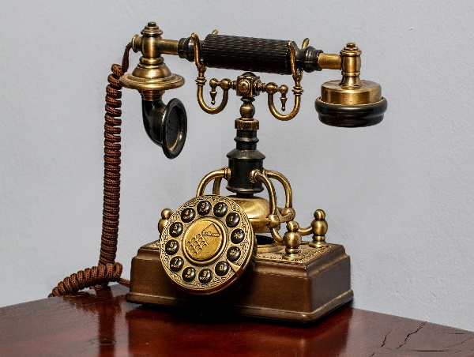

**The Town of Thurman**

**has**

**New Phone Lines!**

PLEASE NOTE THE FOLLOWING

NEW PHONE NUMBERS

FOR THE THURMAN TOWN HALL

Supervisor: 838-766-5013

Secretary: 518-623-9649

Town Clerk: 518-623-4588

Town Court: 518-623-9660

Town Assessor: 518-623-4593

Town Historian: 838-766-5007

Tax Collector: 518-623-2421

Town Highway: 518-623-9614

Town Landfill: 838-766-5012